**DESIGN DOCUMENT**

**Design Flow:-**

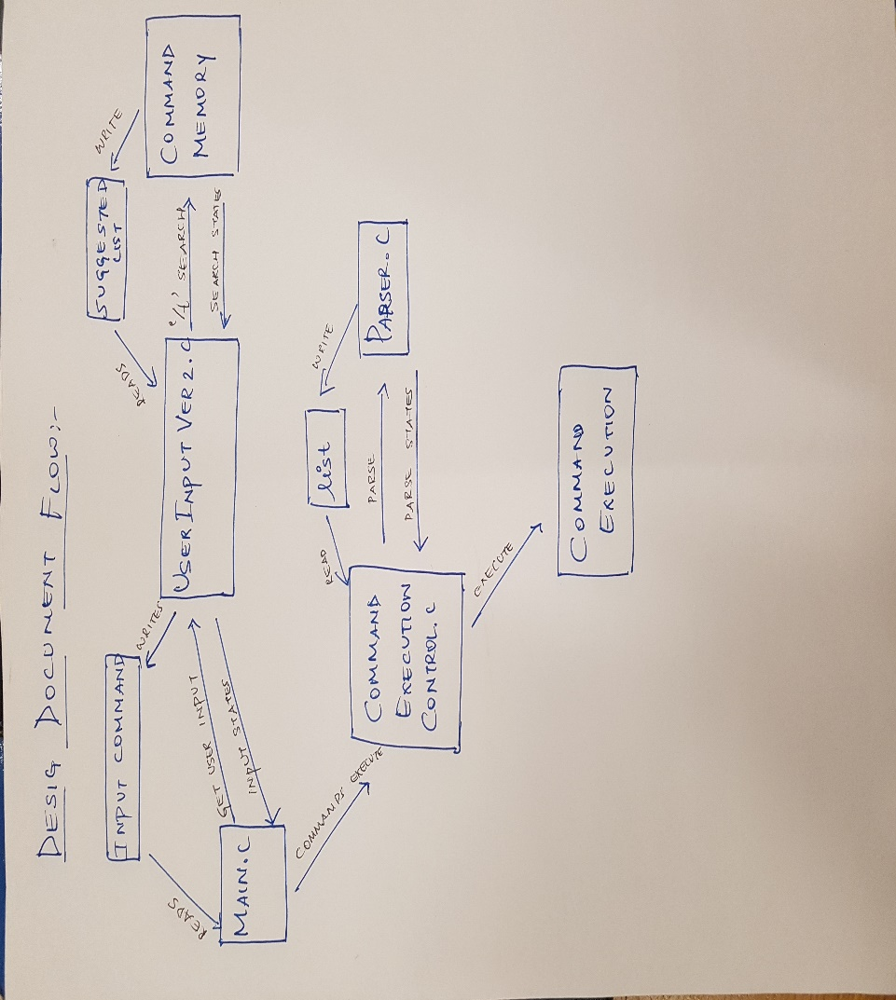

1)th user when gives the input is read by main.c

2)userInput2.c writes the command to input command.

Main .c gets user inputs and also the input states from user input is read in main.c.

3)the command is excetued in Command execution controller.c

4)Parser.c uses the input of lists and reads the input from list and is executed in Parse.c.

5)the command is ececuted in command execution.c

Exception :-

